1. 
2. 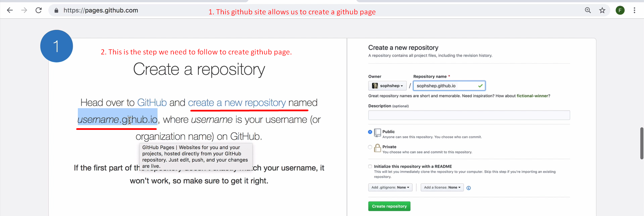
3. 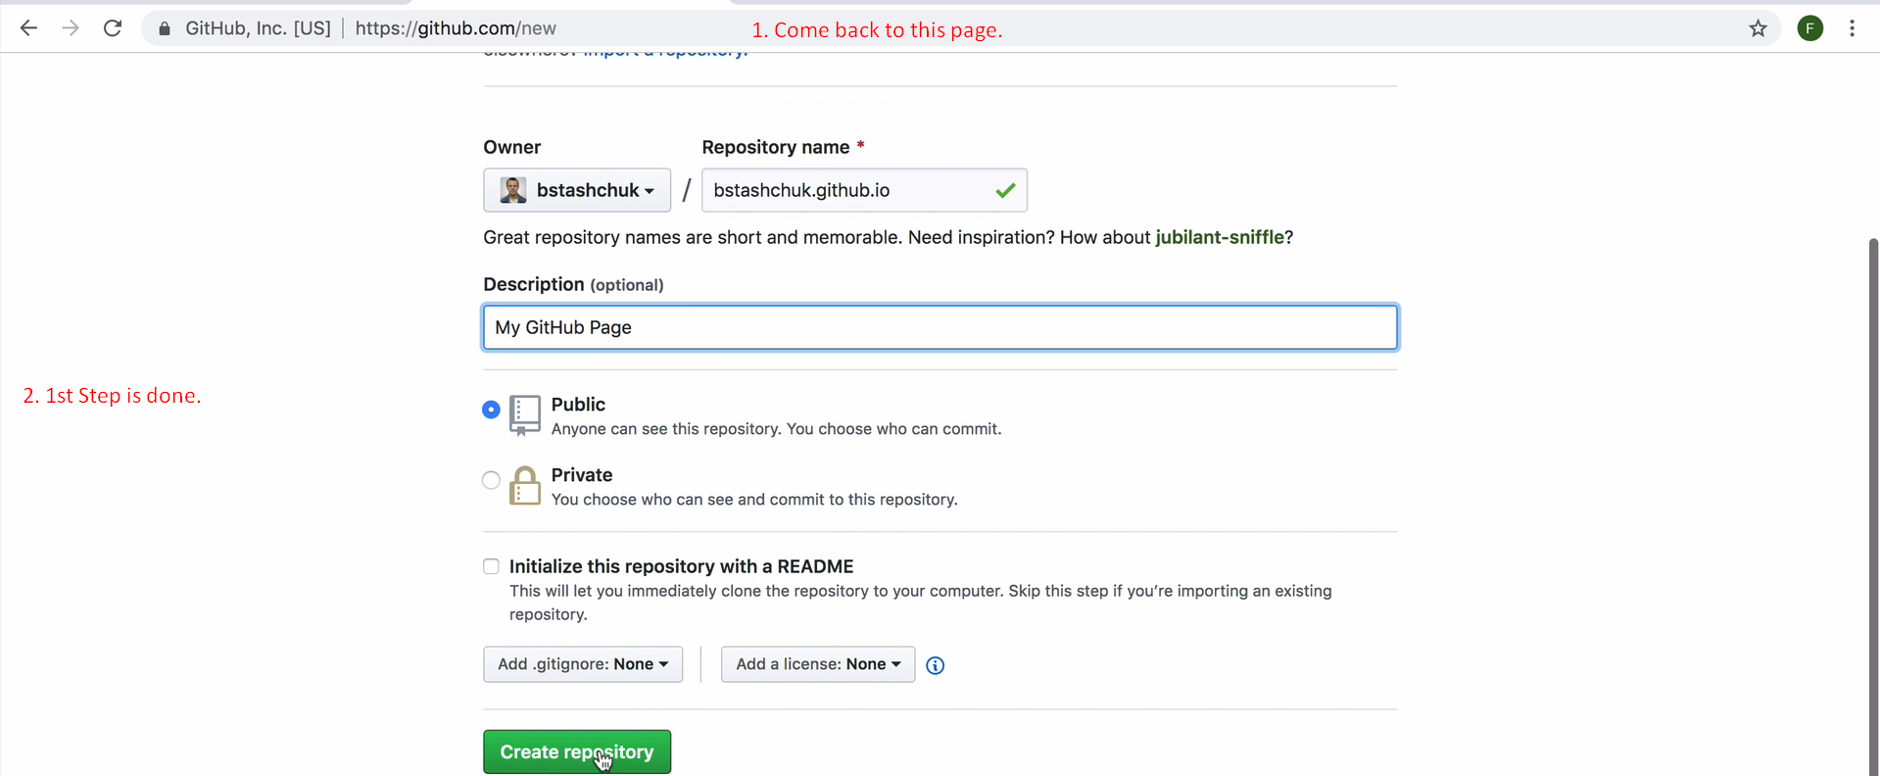
4. 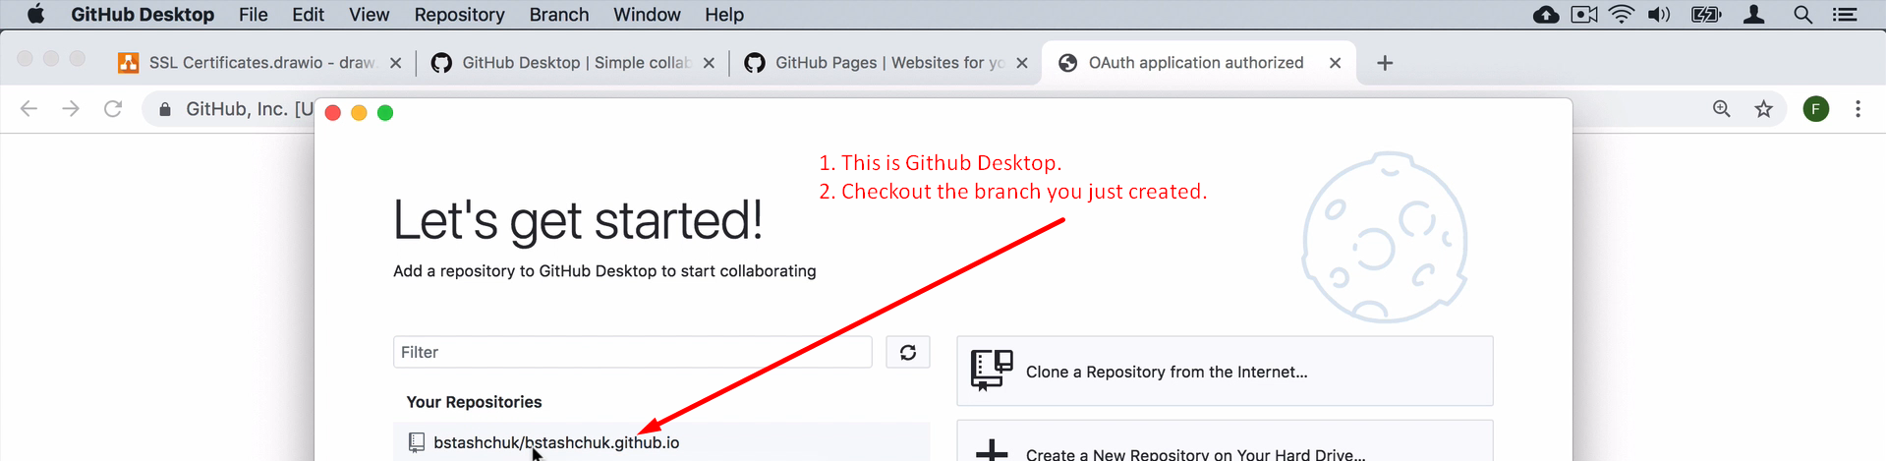
5. 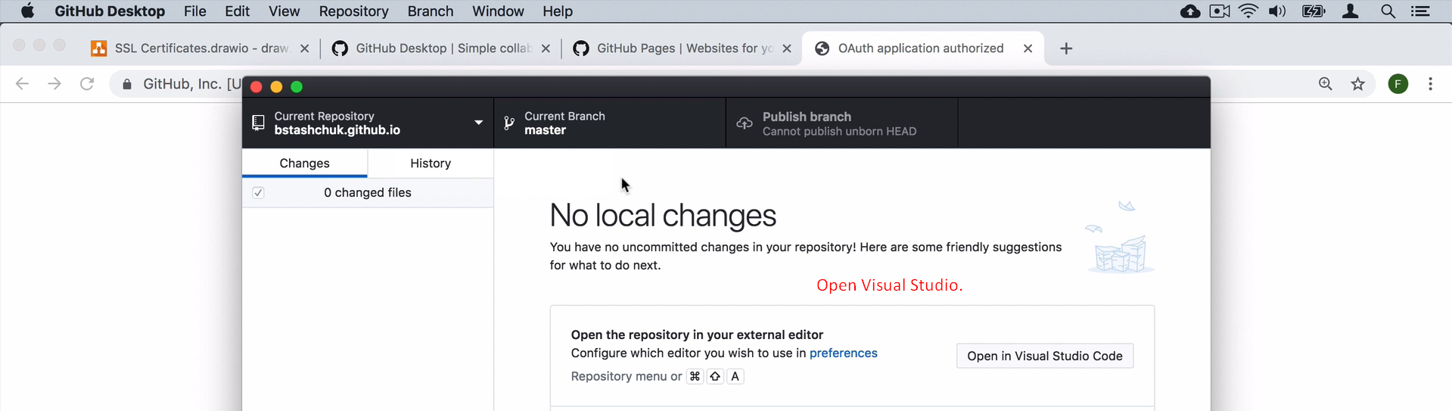
6. 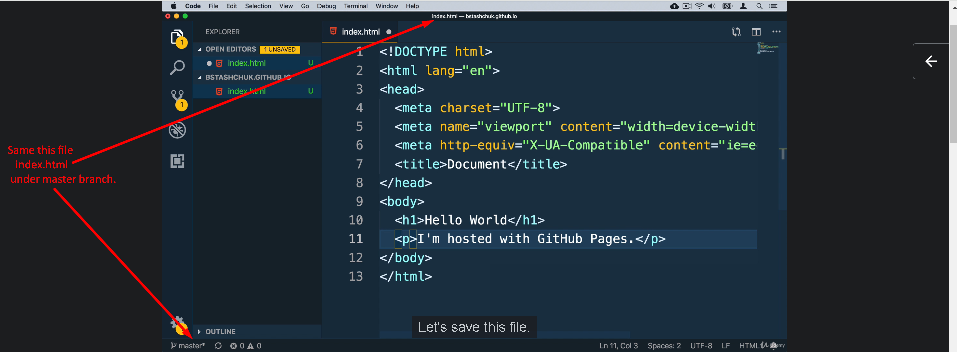
7. Commit the changes and publish them to the master branch.
8. 